|  |
| --- |
| AIC, MATHEMATICS LEARNING AREA  **YEAR 12 MATHEMATICS APPLICATIONS – UNIT 3**  **Assessment Type: Response - 7%**  **TASK 4 - TEST 3 –** **Term 1, Week 9**  **CALCULATOR-ALLOWED**  **Syllabus Content:** 3.3.1 – 3.3.7 Graphs and Networks |

Student Name: __________________________________________

ID: _______ Date: _______

**TIME ALLOWED: 35 minutes** under test conditions

**Section 1: 15 minutes**

**Section 2: 35 minutes**

**MATERIAL REQUIRED / RECOMMENDED FOR THIS PAPER:**

*TO BE PROVIDED BY THE SUPERVISOR*

Question/answer booklet.

*TO BE PROVIDED BY THE CANDIDATE*

*Standard Items:* pens, pencils, pencil sharpener, highlighter, eraser, ruler. Classpad, scientific calculator

**IMPORTANT NOTE TO CANDIDATES**

No other items may be taken into the examination room. It is **your** responsibility to ensure that you do not have any unauthorised notes or other items of a non-personal nature in the examination room. If you have any unauthorised material with you, hand it to the supervisor **before** reading any further.

**Structure of this paper**

|  |  |  |  |  |
| --- | --- | --- | --- | --- |
|  | Number of questions available | Number of questions to be attempted | Suggested working time (minutes) | Marks available |
| **Calculator Assumed** | **7** | **7** | **50 minutes** | **50** |
|  | | | **Marks available:** | **/50** |
| **Task Weighting** | 7% |

**Instructions to candidates**

* The rules for the conduct of this examination are detailed in the booklet *WACE* *Examinations*

*Handbook*. Sitting this examination implies that you agree to abide by these rules.

* Answer the questions in the spaces provided.
* Spare answer pages can be used. If you need to use them, indicate in the original answer space where the answer is continued.

Question 1 (8 marks)

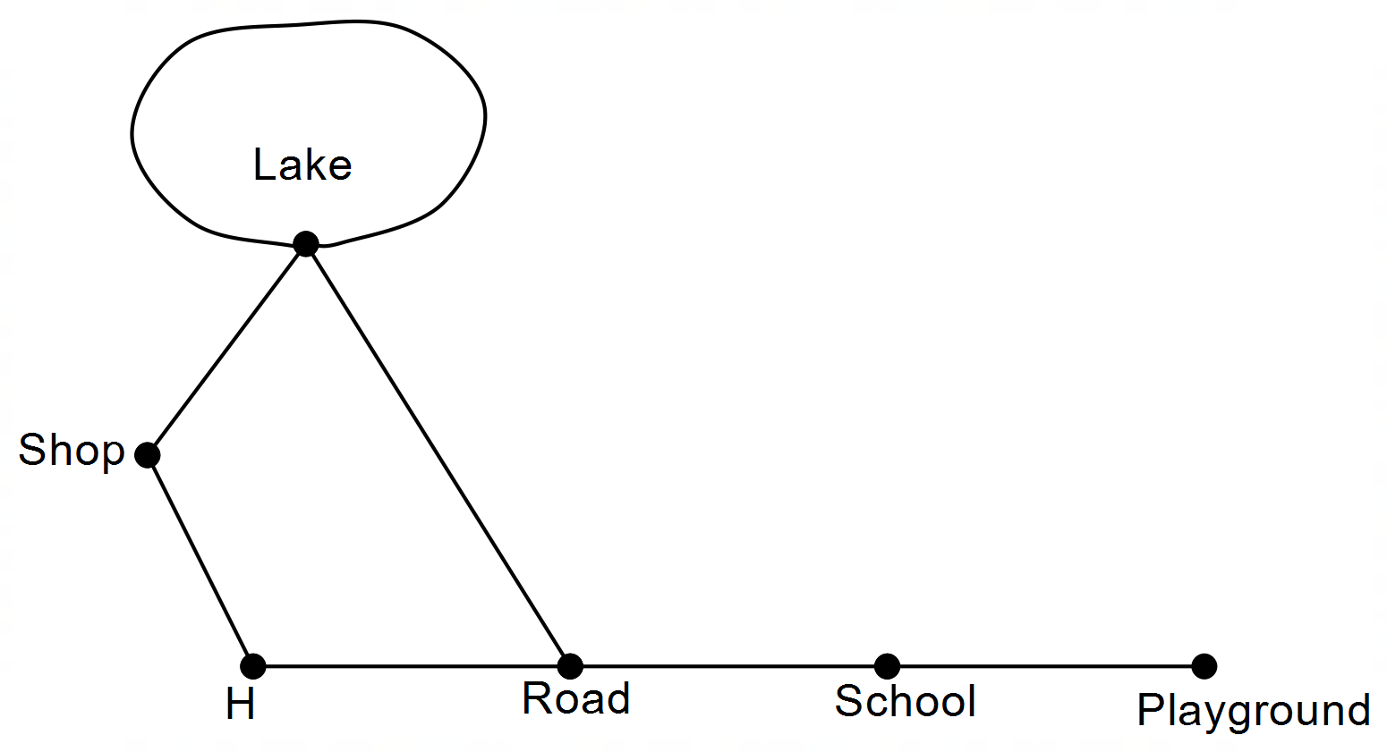Gemma has several walking paths near her home (H). The arcs on the network below show these paths.

(a) Explain why the graph is planar. (1 mark)

**No edges cross one another ü**

(b) Show that Euler’s rule is true for this graph. (2 marks)

**V + F = E + 2**

**6 + 3 = 7 + 2 üü**

(c) Construct the adjacency matrix for this graph.   
(Note: R is road, Sc is school, P is playground, Sh is shop, L is lake) (3 marks)

|  |  |  |  |  |  |  |  |
| --- | --- | --- | --- | --- | --- | --- | --- |
|  |  | **TO** | | | | | |
|  |  | HOME | ROAD | SCHOOL | PLAYGROUND | SHOP | LAKE |
| **FROM** | HOME | **0** | **1** | **0** | **0** | **0** | **0** |
| ROAD | **1** | **0** | **1** | **0** | **0** | **1** |
| SCHOOL | **0** | **1** | **0** | **1** | **0** | **0** |
| PLAYGROUND | **0** | **0** | **1** | **0** | **0** | **0** |
| SHOP | **1** | **0** | **0** | **0** | **0** | **1** |
| LAKE | **1** | **1** | **0** | **0** | **1** | **0** |

(d) For Gemma to walk from home on a walk of length five, list the sequence of nodes she would visit to:

(i) get back home. (1 mark)

**H Shop Lake Lake Road H (various)** **ü**

(ii) get to school. (1 mark)

**H Shop Lake Lake Road School (various) ü**

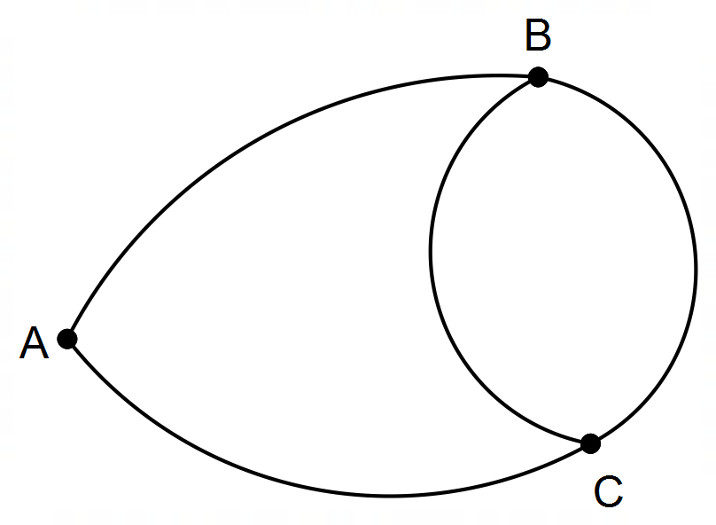**Question 2 (8 marks)**

(a) Why is the network above not simple? (1 mark)

**There are multiple edges joining B and C ü**

(b) This graph is not a digraph. Why? (1 mark)

**There are no directed paths ü**

(c) This graph is semi-Eulerian. Give the reason. (1 mark)

**The graph has two odd nodes ü**

(d) State a Hamiltonian cycle. (1 mark)

**ABCA (other solutions exist) ü**

(e) How many semi-Hamiltonian paths are there starting at B? (1 mark)

**3 ü**

A B C D

A matrix M2 =

M2 describes the two-stage paths in a simple graph.

(f) Complete the graph representing M. (3 marks)

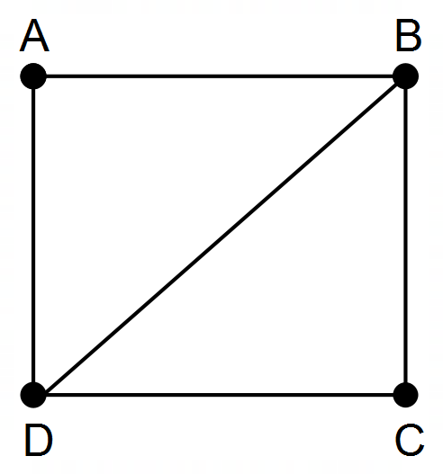

**üüü**

**Question 3 (9 marks)**

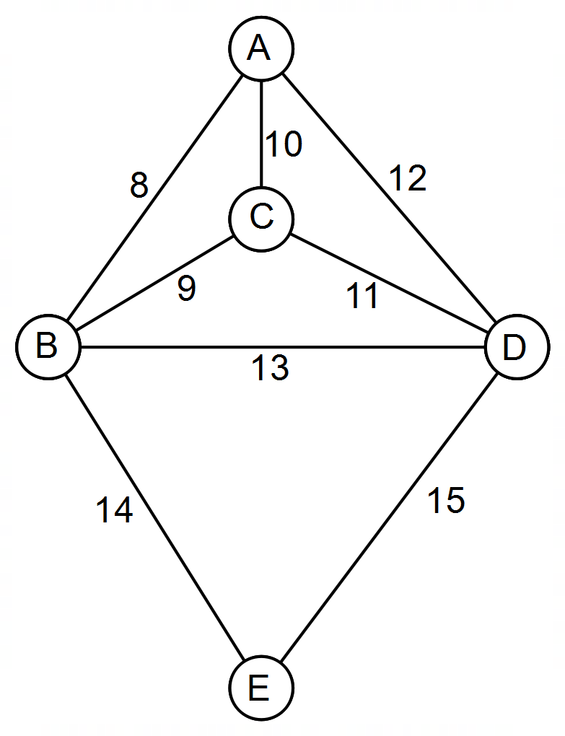Consider the following map showing five towns joined by roads. Distances are given in kilometres.

Barney is a travelling salesman, and starting from A, he wishes to visit all the other towns; B, C, D and E, and return to A by the shortest route possible in no order.

(a) From your knowledge of graph theory, what name is given to such a route? (2 marks)

(b) What is the shortest route he will travel? State the path and its length. (2 marks)

James is a postman and also begins at A. He wishes to travel each road delivering letters as he goes.  
Barney suggests that James can travel each road exactly once and get back to A.

(c) Barney isn’t correct. Explain. (2 marks)



*DIAGRAM REDRAWN FOR YOUR CONVENIENCE*

James thinks that if a new road was built, then he could get back to A, having only visited each road once.

(d) Where would the road be built? (1 mark)

Alyce drove a distance of 33 km, starting at a town and ending at another town.

(e) What route(s) would she have taken? (2 marks)

**Question 4 (5 marks)**

|  |  |
| --- | --- |
| **<EFOFEX>  id:fxd{107ef678-4cfb-4269-84a0-f637710bfd4c}   FXData:  </EFOFEX>** |  |

The directed bipartite graph above represents a dog agility course. Tunnels are represented by $T$ and obstacles are represented by $O$.

For example, tunnel $T_{1}$ takes dogs to obstacles $O_{1}$ and $O_{2}$, whereas once a dog has cleared obstacle $O_{5}$ they then enter tunnel $T_{3}$. Isabel wants her dog, Jasper, to complete the agility course.

She wants Jasper to pass through all the tunnels, and to clear each obstacle, once only.

(a) (i) If Jasper is to return to where he started, what is the mathematical term for the closed path Jasper must take. (1 mark)

|  |  |
| --- | --- |
| Solution | Specific behaviours |
| **Hamiltonian cycle** | * **States Hamiltonian cycle.** |

(ii) Explain why it is not possible for Jasper to return to his starting point without repeating a tunnel. (1 mark)

|  |  |
| --- | --- |
| Solution | Specific behaviours |
| **Obstacle 1 can only be accessed from Tunnel 1, which then returns Jasper to Tunnel 1.** | * **Explains noting the issue with Obstacle 1.** |

Isabel decides that Jasper does not need to return to where he started.

(b) Determine the path that allows Jasper to complete the agility course, passing through each tunnel once, and completing each obstacle once. (2 marks)

|  |  |
| --- | --- |
| Solution | Specific behaviours |
| $$O_{1} T_{1} O_{2} T_{2} O_{4} T_{4} O_{5} T_{3} O_{3}$$ | * **Path starts at Obstacle 1 or 3.** * **Path passes through each tunnel and obstacle once and only once.** |

**<EFOFEX>

id:fxd{107ef678-4cfb-4269-84a0-f637710bfd4c}


FXData:

</EFOFEX>**

*DIAGRAM REDRAWN FOR YOUR CONVENIENCE*

Jasper passes through tunnel $T_{4}$ and then decides to enter tunnel $T_{3}$, skipping obstacle $O_{5}$.

(c) Why can this information not be represented in a bipartite graph? (1 mark)

|  |  |
| --- | --- |
| Solution | Specific behaviours |
| **This would be an edge from $T_{4}$ to $T_{3}$, but a bipartite graph cannot have edges between two elements in the same group.** | * **Clearly explains why this is no longer a bipartite graph.** |

Question 5 (6 marks)

(a) A connected planar graph has $14$ vertices and $9$ faces. Determine the number of edges this graph has. (2 marks)

|  |
| --- |
| Solution |
| Using Euler's formula $14+9-e=2⇒e=21$ Hence graph has $21$ edges. |
| Specific behaviours |
| ü correct use of Euler's formula  ✓ correct number of edges |

(b) The vertices in the following graph can be split into two distinct groups to demonstrate that the graph is bipartite. List the vertices in each group. (2 marks)

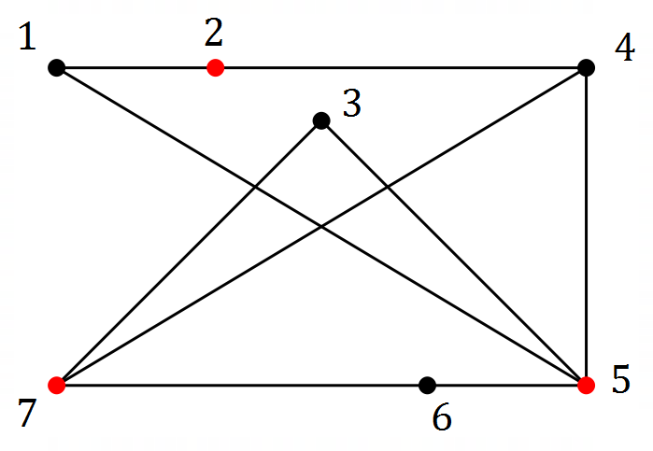

|  |
| --- |
| Solution |
| Groups are $\{1, 3, 4, 6\}$ and $\{2, 5, 7\}$ |
| Specific behaviours |
| ü marks alternate vertices/redraws  ✓ correctly lists groups |

(c) Determine the number of edges that must be removed from a complete graph with $5$ vertices so that it becomes a tree with $5$ vertices. (2 marks)

|  |
| --- |
| Solution |
| $K_{5}$ has $5×4÷2=10$ edges.  Tree with $5$ vertices has $4$ edges.  Hence remove $10-4=6$ edges. |
| Specific behaviours |
| ü edges in $K_{5}$ ✓ correct number to remove |

Question 6 (7 marks)

The edge weights on the graph below represent the time, in milliseconds, to send a data packet between routers on a computer network, represented by the vertices.

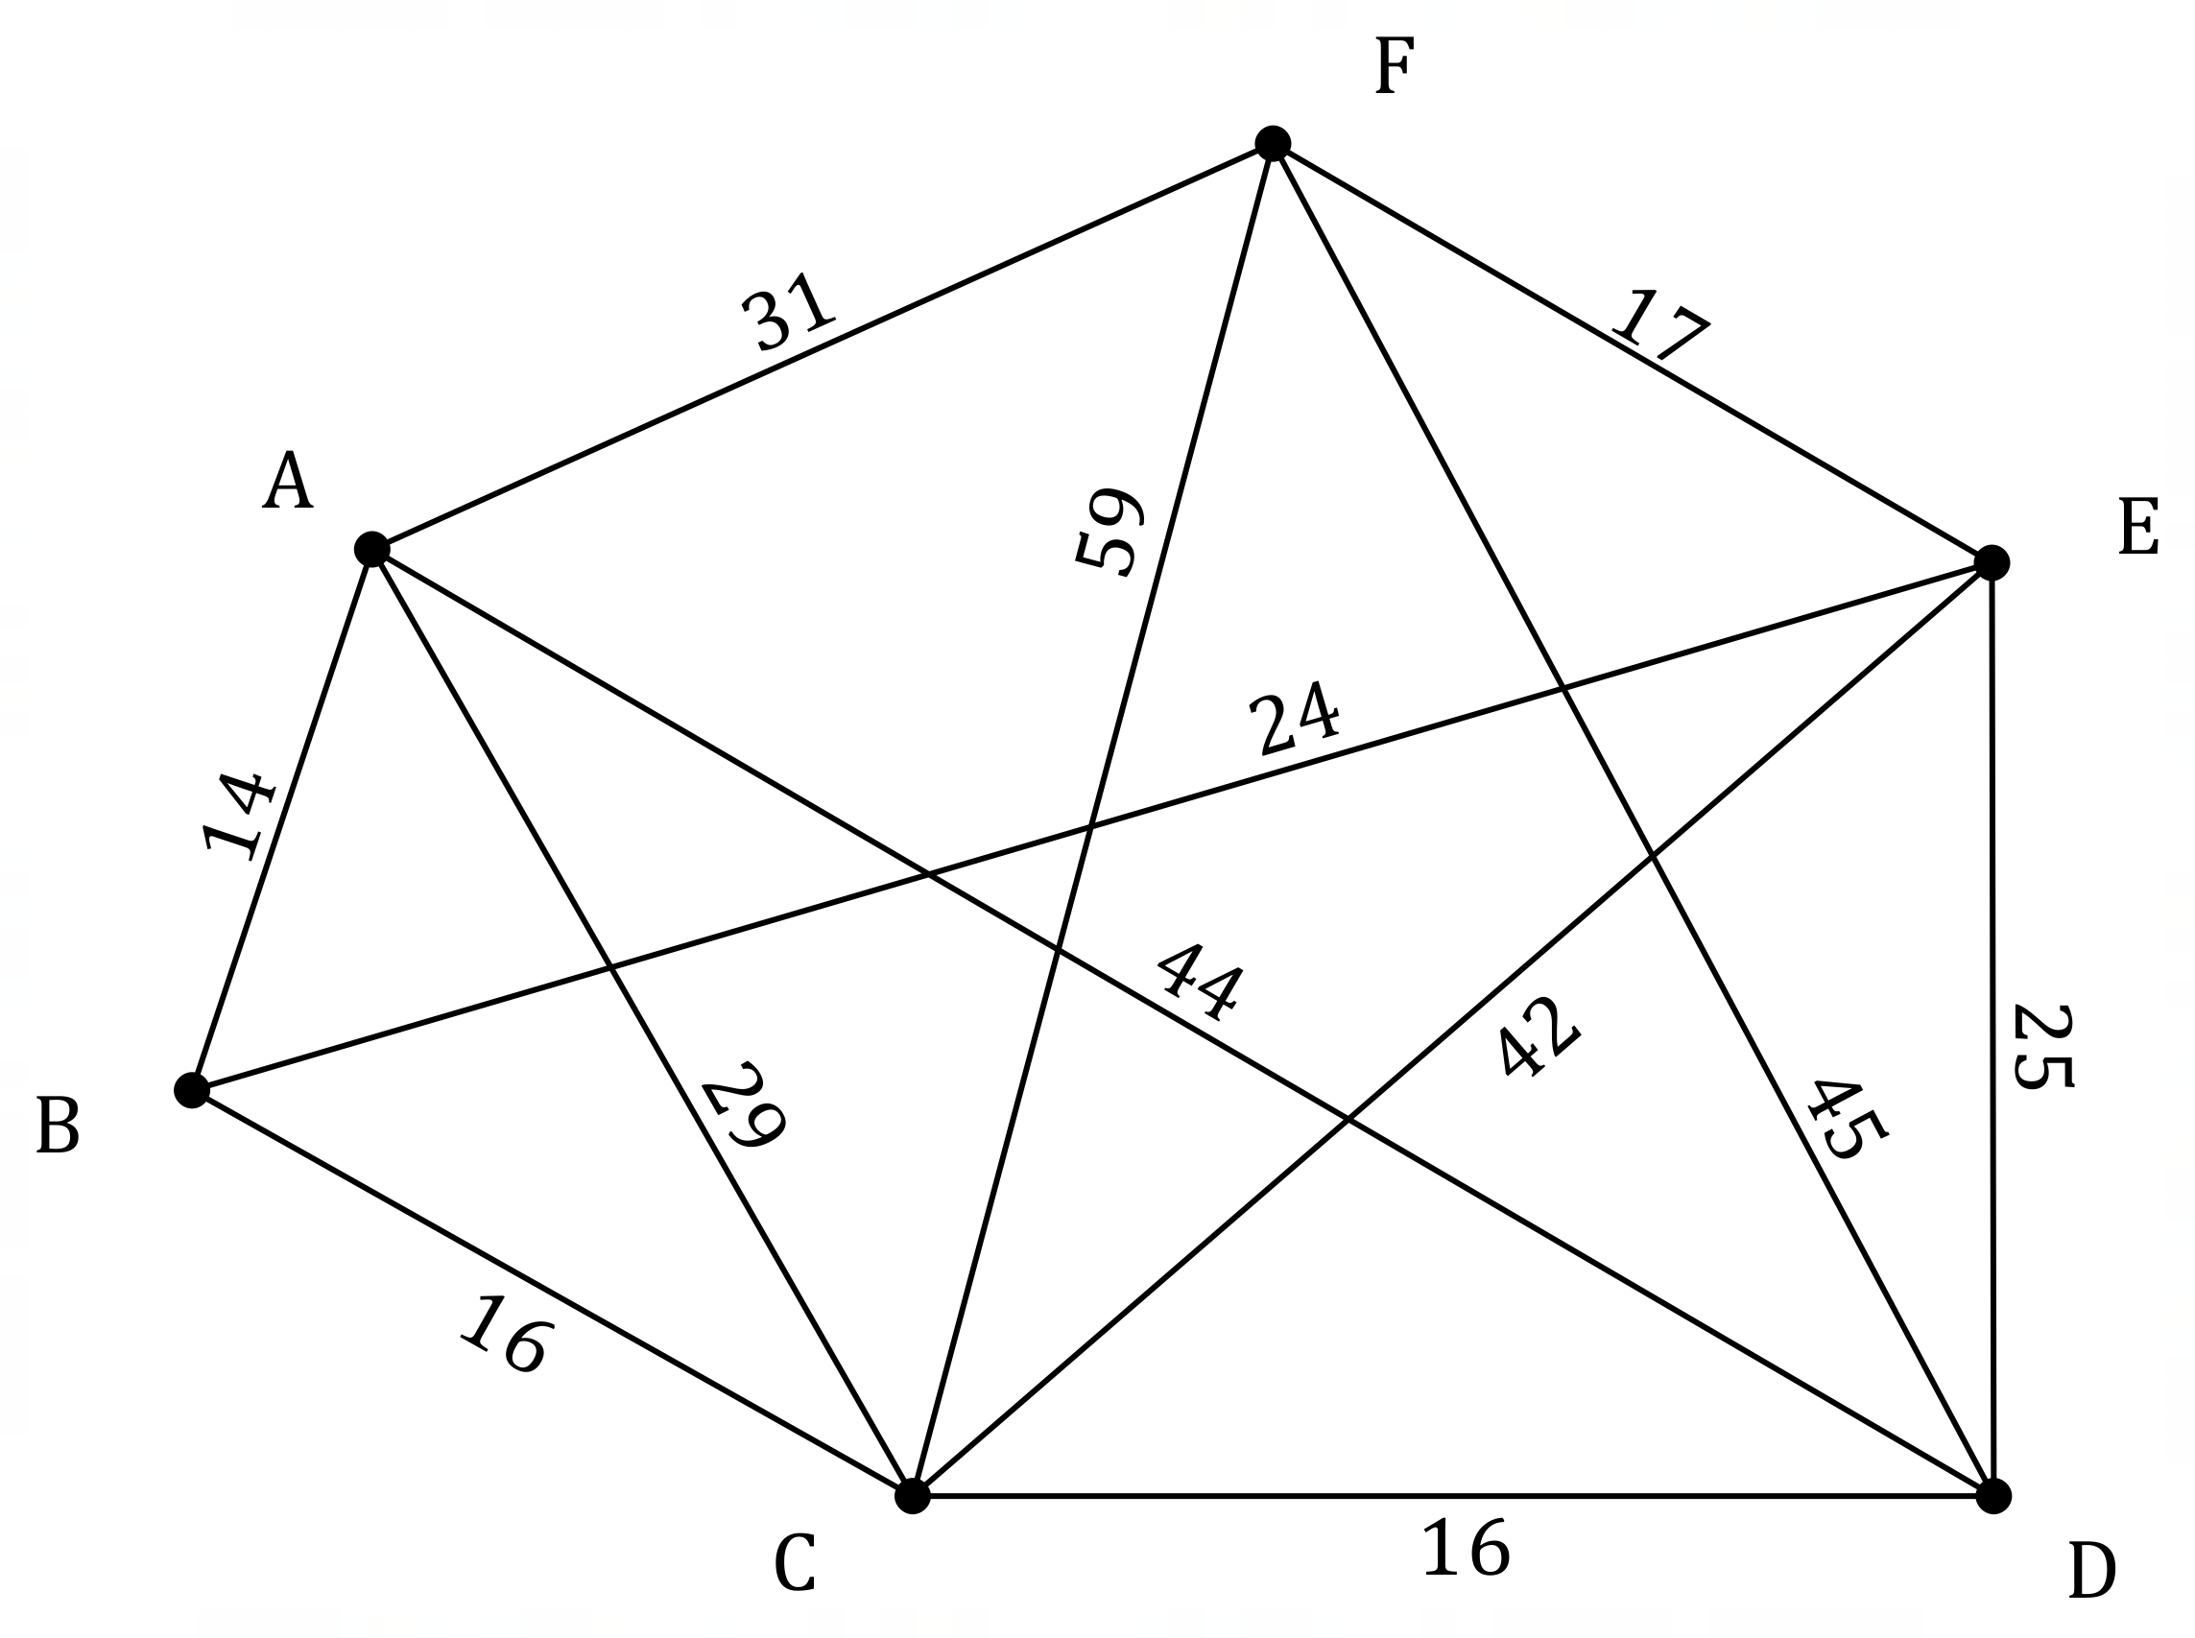

(a) Determine the minimum time to send a data packet from router $C$ to router $F$ and state, in order, the routers on this path. (3 marks)

|  |
| --- |
| Solution |
| Routers on path: $CBEF$ Minimum time: $16+24+17=57$ milliseconds. |
| Specific behaviours |
| ü evidence of checking times for at least two paths  ✓ correct path  ✓ correct minimum time |

(b) Explain, with justification, why the graph in this question is Hamiltonian. (2 marks)

|  |
| --- |
| Solution |
| The graph contains a cycle that visits all vertices. For example, the cycle $ABCDEFA$. |
| Specific behaviours |
| ü explanation using **cycle** and **all vertices**  ✓ example of Hamiltonian cycle in graph |

(c) State, with reasoning, the least number of edges that must be removed from the graph so that it is no longer Hamiltonian. (2 marks)

|  |
| --- |
| Solution |
| $2$ edges. By removing any $2$ of the $3$ edges from vertex $B$ the graph will become semi-Hamiltonian. |
| Specific behaviours |
| ü correct number  ✓ reasoning |

Question 7 (7 marks)

A student found a box containing three keys and four padlocks. Some keys will open more than one padlock. A tick in the following table indicates that a key will open that padlock.

|  |  |  |  |  |  |
| --- | --- | --- | --- | --- | --- |
|  |  | Padlock | | | |
|  |  | $$1$$ | $$2$$ | $$3$$ | $$4$$ |
| Key | $$A$$ | ✓ | ✓ |  |  |
| $$B$$ | ✓ | ✓ | ✓ | ✓ |
| $$C$$ |  |  | ✓ | ✓ |

(a) Represent this information clearly as a bipartite graph $G$. (3 marks)

|  |
| --- |
| **Solution** |
|  |
| **Specific behaviours** |
| ü two distinct sets of vertices  ✓ all vertices labelled  ✓ correct set of edges |

(b) The presence of all even vertices in $G$ indicates that it is Eulerian. State the definition of an Eulerian graph. (2 marks)

|  |
| --- |
| **Solution** |
| An Eulerian graph contains a closed trail that includes every edge once only. |
| **Specific behaviours** |
| ü states has an **closed trail**  ✓ states trail **includes every edge once only** |

(c) If another edge was added to $G$, from key $A$ to padlock $4$, state, with reasons, whether $G$ is still:

(i) bipartite. (1 mark)

|  |
| --- |
| **Solution** |
| Yes - the extra edge joins vertices in different sets. |
| **Specific behaviours** |
| ü states yes, with reason |

(ii) Eulerian. (1 mark)

|  |
| --- |
| **Solution** |
| No - graph will become semi-Eulerian. |
| **Specific behaviours** |
| ü states no, with reason |

SPARE QUESTION:

Question 9 (7 marks)

The vertices $A$ to $G$ in the graph below represent major bus stations in a city and the edge weights represent the travel time between pairs of stations in minutes.

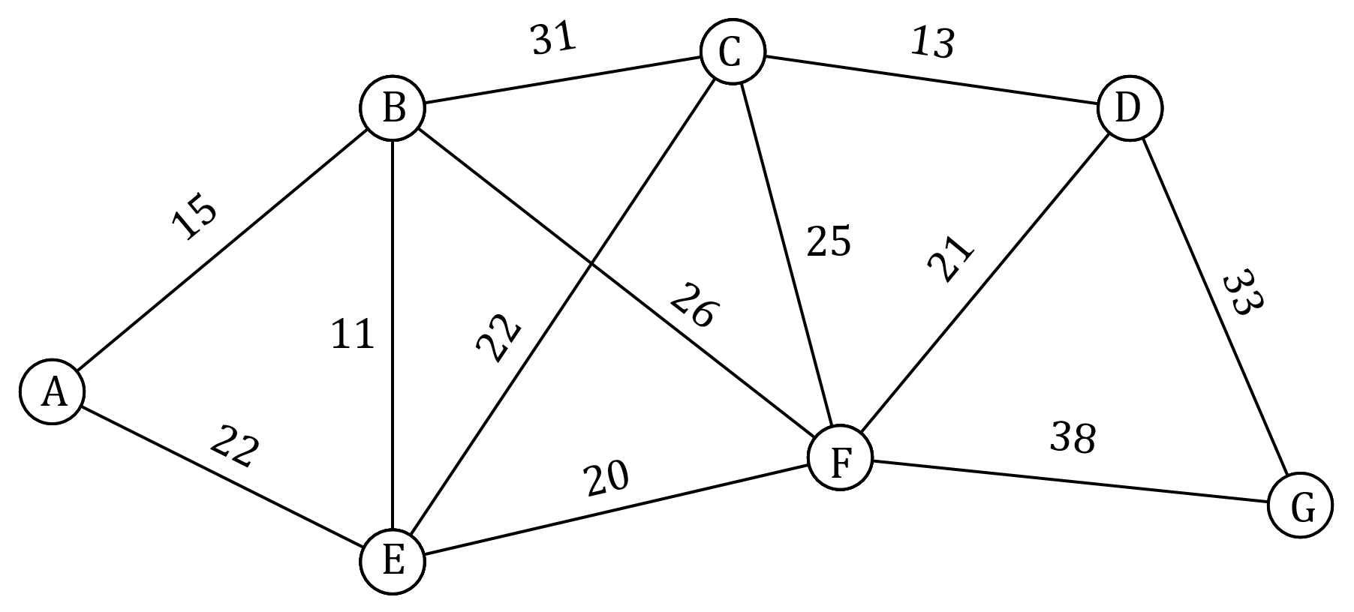

(a) Determine the minimum travel time and corresponding route between the following pairs of stations:

(i) $D$ and $E$. (2 marks)

(ii) $A$ and $G$. (3 marks)

(b) It is possible to reduce the travel time between stations $E$ and $F$. Determine the reduction required so that the current minimum travel time between stations $B$ and $G$ is equal to the minimum travel time between these stations, via station $E$, after the reduction.

(2 marks)